Bombardier Bombi Undercarriage

I bought two Alpine Guide Hard rubber tire & wheel assemblies for the back idler
and two Alpine Guide close cell solid tire & wheel assemblies for the front below
the sprocket.
To put the back idler on a Bombi, you have to break the track. Breaking the track at
the belt overlap is easy. The belts are overlapped under two grousers. Take the
10 bolts out and pry the belts apart. The tracks will roll off the back idler.

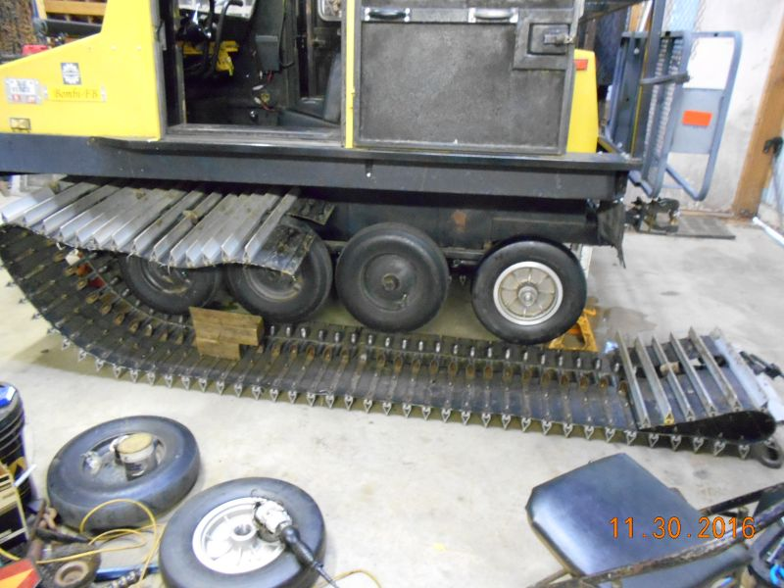

This makes it real easy to put the new Alpine Guide Hard rubber tire & wheel
assembly on for the back idler. After hand packing the new bearings and putting in
the new seal... I did find that the new wheel is machined different than the old
wheel. The castle nut threads on to far for the cotter pin to lock it in
position.

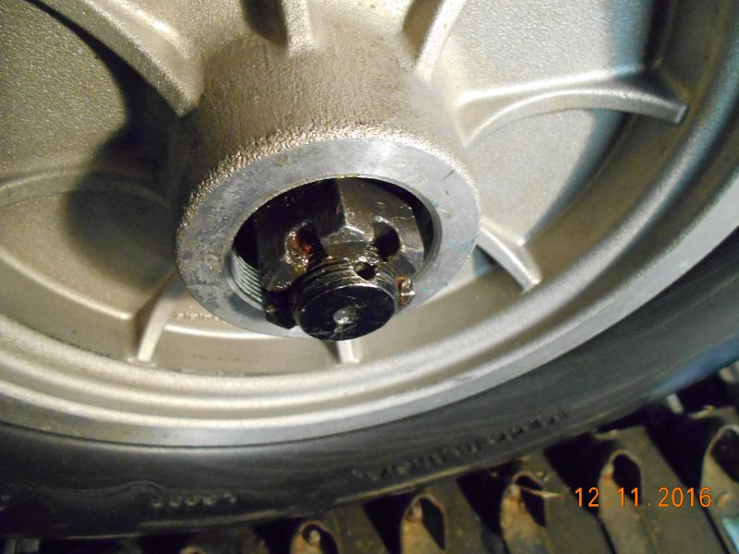

So what I did was to turn out two 7/8" flat washers so they would go on the spindle.
(two spaced the castle nut out to where the cotter pin locked it up right.)
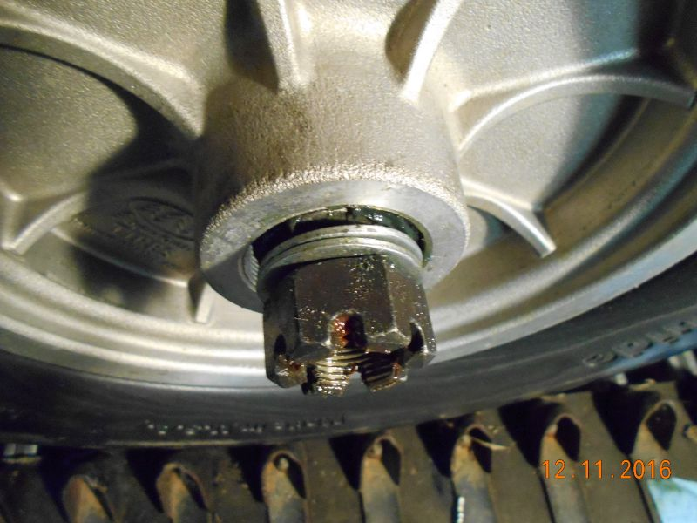

After tightening the castle nut for right preload I placed the cotter pin.
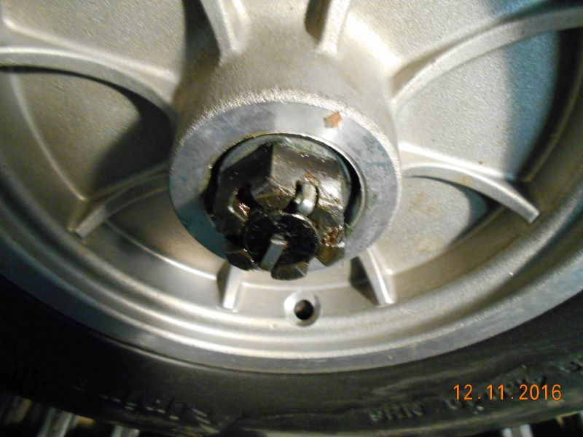

I then placed Alpine Guides Bearing Buddy on and called it complete.
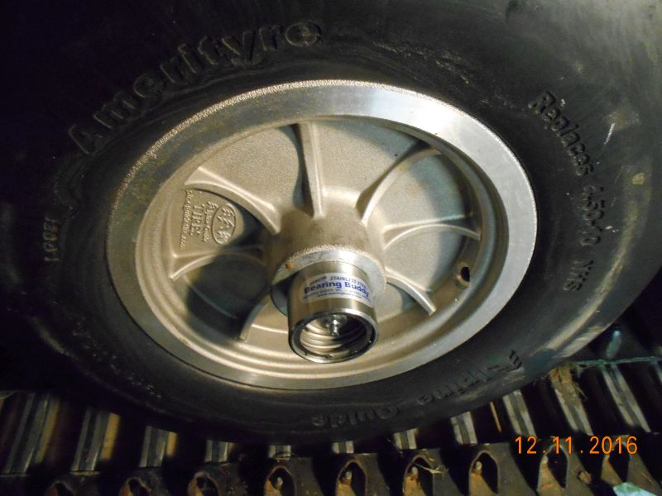

I then humped the track over the front sprocket to install the front
Alpine Guide close cell solid tire & wheel assembly.
Same washers turned out & installed for the new front wheel as for the back idler.
I also pulled the two middle wheels and cleaned the bearings for inspection.
Replaced one bearing and race and installed new seals. Hand packed the new
bearings with grease and reinstalled them.
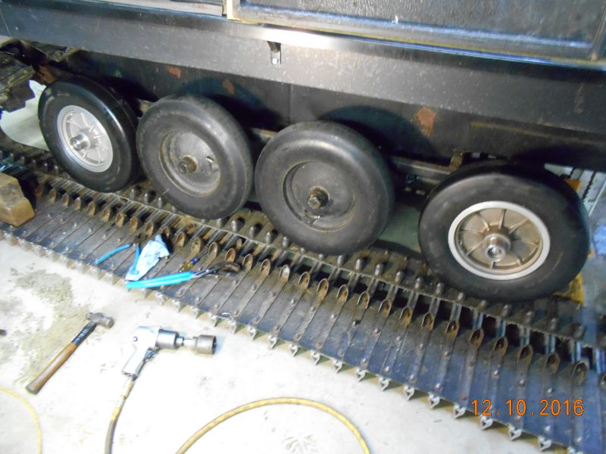

I then rolled the track back over the sprocket and center wheels.
Put a small chain around a grouser forward of the overlap and one around a
grouser to the rear... hooked a come-along between them and pulled the track together
somewhat close. I noticed that pulling in this off center way the holes in the belts
were not lining up. So stuck two 5/8" rods clear through a grouser on each side of
the overlap... hooked a winch strap between the two rods inside & out. This allowed
me to pull each side of the track individually making it possible to line up the holes in
the overlapping belts. The clamped 2x4 kept everything flat.

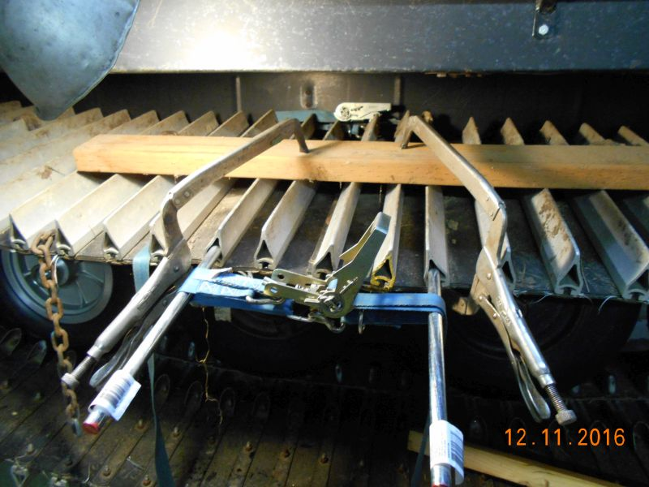

I do suggest replacing the bolts that go from the grouser through the belting and
inside guides before reinstalling the grousers. (1/4" longer bolts makes it much easier
to get the nuts started)
After you get about two bolts started... I found it easier after I rolled the track around
until the overlap was between the sprocket & the first front wheel.
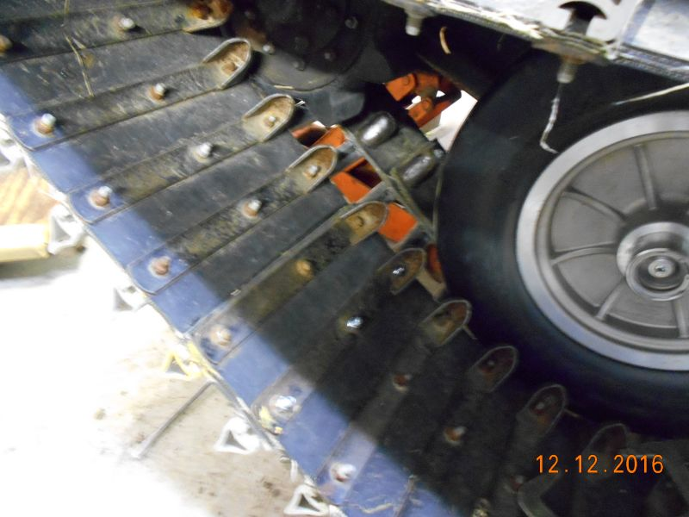

After tightening up all the overlap bolts, I greased the bearing buddies and
tightened the track. Ran the cat in gear while it was still jacked up to test
everything and called it good.
Before track tensioning
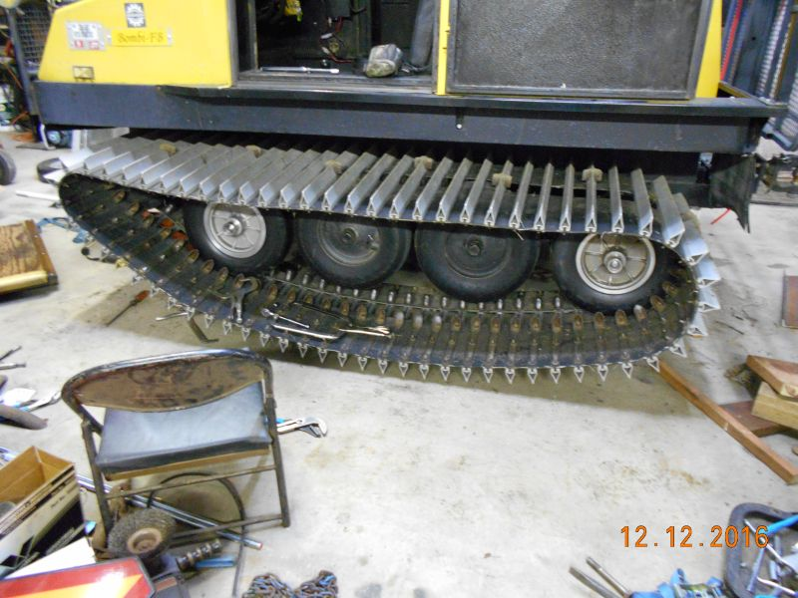

Tensioned up both tracks and ran it up and down the driveway some. Re tensioned
tracks and called it good to go. Loaded up the Bombi and took it to the WA7HJR
repeater sit on Tiger Mt a couple of days later. Worked fine.
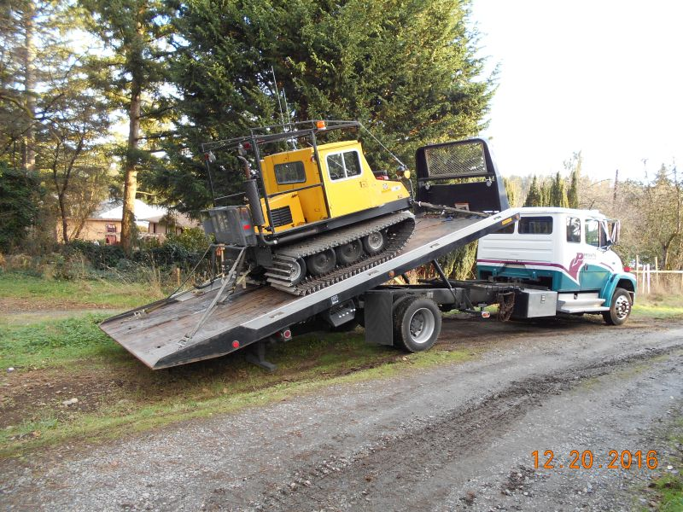

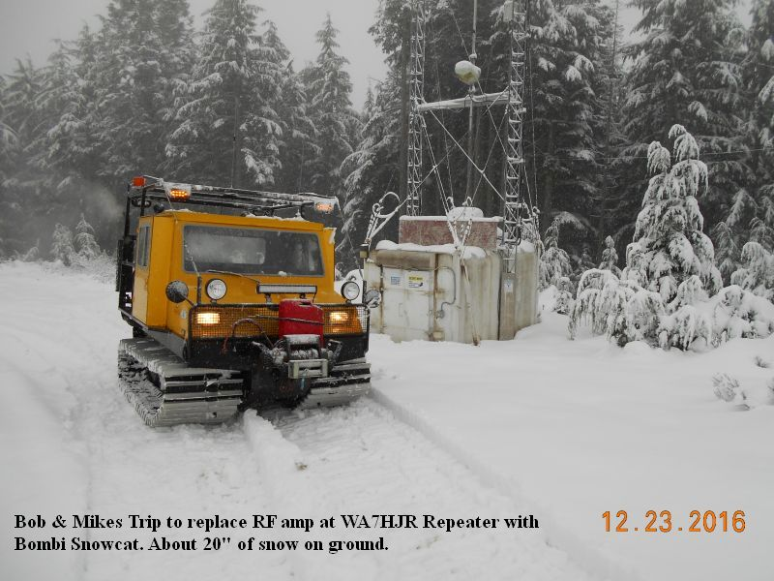

This project should make the Bombi more reliable.

